WEEK 5 INTERNSHIP REPORT

Comprehensive Data Science Project Reporting and Strategic Recommendations

Internship :Data Science with Python Internship

Project Title: Student Academic Performance Analysis and Predictive Modeling

Dataset: Student Performance Dataset

Tools Used: Python, Google Colab, Pandas, NumPy, Matplotlib, Seaborn, SciPy and Scikit-learn

Prepared By : Gunasalini

INTRODUCTION:
Data science provides a structured approach for transforming raw data into meaningful information that can support analysis and decision-making. A complete data science project usually involves multiple stages, including acquiring relevant data, checking its quality, exploring patterns, visualizing results, applying statistical methods, developing predictive models, and interpreting the results.
This project focused on analysing student academic performance using the Student Performance dataset. The dataset contains information about students studying Mathematics and Portuguese, including demographic characteristics, family background, study habits, previous academic failures, social factors, absences, and grades.The internship was organised as a progressive five-week learning process. Week 1 focused on data acquisition, cleaning, preprocessing, and exploratory analysis. Week 2 focused on advanced visualization and data storytelling. Week 3 introduced statistical analysis and hypothesis testing. Week 4 focused on machine learning model development and evaluation. Finally, Week 5 integrated the work completed in the previous weeks into a comprehensive end-to-end data science project. The purpose of this final project was not only to identify patterns in student performance but also to convert those findings into meaningful and practical recommendations. The project demonstrates how different data science techniques can work together to provide a broader understanding of a real-world problem.

EXECUTIVE SUMMARY:
This comprehensive project integrates the major stages of the data science workflow completed during the five-week internship. The project focused on analysing student academic performance using the Student Performance dataset. The complete workflow included data acquisition, data cleaning and preprocessing, exploratory data analysis, advanced data visualization, statistical hypothesis testing, machine learning model development, model evaluation, and strategic recommendations. The analysis combined student records from Mathematics and Portuguese courses, resulting in a dataset containing 1,044 records and 34 columns after adding a subject identifier. The dataset contained academic, demographic, family, social, and lifestyle-related information. Data quality checks confirmed that the combined dataset contained no missing values and no duplicate rows, allowing the analysis to proceed without imputation or duplicate removal.
Exploratory analysis identified several patterns related to student performance. Previous academic failures showed the strongest negative relationship with final grade among the numerical background factors analysed. Study time, parental education, and educational aspirations showed positive associations with academic performance. Students who intended to pursue higher education had substantially higher average final grades than those who did not.
Statistical hypothesis testing was used to examine whether students with higher study time achieved significantly different final grades compared with students with lower study time. The analysis compared 820 students in the Lower Study Time group with 224 students in the Higher Study Time group. The Higher Study Time group had a mean final grade of 12.43, compared with 11.04 for the Lower Study Time group, providing evidence of a meaningful difference in academic performance.
For machine learning, students were classified into Lower Performance and Higher Performance groups using a final-grade threshold of 12. Logistic Regression was selected as the primary model, and a Decision Tree Classifier was developed for comparison. Logistic Regression achieved 65.07% accuracy, 62.83% precision, 69.61% recall, 66.05% F1-score, and a ROC-AUC of 0.7076. It performed better overall than the Decision Tree model, although its performance remained moderate. Based on the complete analysis, this report presents strategic recommendations focused on early intervention for students with previous failures, encouraging effective study habits, strengthening educational aspirations, monitoring extremely high absenteeism, improving access to learning resources, and using data analysis as a supporting tool for educational decision-making.

PROJECT OBJECTIVES:
The major objectives of the comprehensive project were:
- To acquire and prepare a publicly available student performance dataset.
- To check the dataset for missing values, duplicate records, and data quality issues.
- To perform exploratory data analysis and identify important patterns in student performance.
- To create clear visualizations that communicate findings to a non-technical audience.
- To statistically examine the relationship between study time and final academic performance.
- To develop and evaluate machine learning models for classifying student performance.
- To compare different machine learning approaches using appropriate evaluation metrics.
- To integrate findings from exploratory analysis, statistical testing, and machine learning.
- To develop strategic recommendations based on the results of the complete analysis.
- To identify limitations and potential areas for future improvement.

DATASET DESCRIPTION:
The Student Performance dataset was used throughout the internship. It contains two related datasets:
- Mathematics: 395 student records
- Portuguese: 649 student records
The two datasets were combined for the comprehensive analysis, resulting in:
- Total records: 1,044
- Total columns: 34
- Numerical columns: 16
- Categorical columns: 18
A new column called subject was added to identify whether each record belonged to the Mathematics or Portuguese dataset. The dataset includes information related to:
- Student age and sex
- School and address
- Family size and parental status
- Mother's and father's education
- Parents' occupations
- Travel time
- Study time
- Previous academic failures
- School and family support
- Educational aspirations
- Internet access
- Family relationships
- Free time and social activities
- Alcohol consumption
- Health status
- Absences
- First-period grade (G1)
- Second-period grade (G2)
- Final grade (G3)
The final grade, G3, was used as the main measure of academic performance throughout the project. The dataset structure supported the application of exploratory analysis, statistical testing, visualization, and machine learning.

METHODOLOGY AND PROJECT WORKFLOW:
The project followed an end-to-end data science workflow consisting of five major stages.

Week 1: Data Acquisition, Cleaning and Exploratory Analysis
The dataset was acquired and loaded into Python using Pandas. Data quality checks were performed to identify missing values and duplicate records. Summary statistics and exploratory visualizations were then used to understand the distribution and characteristics of the data.

Week 2: Advanced Data Visualization and Storytelling
Multiple visualizations were developed to communicate patterns in student performance. The visualizations were organised as a data story, beginning with overall academic performance and then examining factors associated with differences in student outcomes.

Week 3: Statistical Analysis and Hypothesis Testing
Students were divided into Lower Study Time and Higher Study Time groups. Descriptive statistics, Levene's test, an independent samples t-test, a confidence interval, and Cohen's d were used to examine whether the difference in final grades between the groups was statistically meaningful.

Week 4: Machine Learning Model Development and Evaluation
A binary student-performance target was created from the final grade. Logistic Regression was used as the primary model, while a Decision Tree Classifier was used for comparison. The models were evaluated using accuracy, precision, recall, F1-score, ROC-AUC, a confusion matrix, and other diagnostic analysis.

Week 5: Project Synthesis and Strategic Recommendations
The findings from the previous weeks were integrated into a comprehensive analysis. Additional comparisons and correlation analysis were performed to identify important factors associated with final academic performance. These findings were then used to develop strategic recommendations.

DATA ACQUISITION, CLEANING AND PREPROCESSING:
The Mathematics and Portuguese datasets were loaded separately using the Pandas read_csv() function. Since the datasets used semicolons as separators, the parameter sep=";" was specified during loading.
Code snippet:
#A subject column was added before combining the datasets:
math_df["subject"] = "Mathematics"
por_df["subject"] = "Portuguese"
#The datasets were then combined:
combined_df = pd.concat(
[math_df, por_df],
ignore_index=True
)
#The resulting dataset contained 1,044 student records and 34 columns.

Data Quality Checks
The dataset was inspected using info() to understand the structure and data types. Missing values and duplicate records were checked using the following approach:
Code snippet:
missing_values = combined_df.isnull().sum().sum()
duplicate_rows = combined_df.duplicated().sum()

Results
- Total missing values: 0
- Number of duplicate rows: 0
Because no missing values or duplicate records were found, unnecessary modifications were avoided. A clean working copy of the dataset was created for further analysis.
This step was important because data cleaning should be based on actual problems found in the dataset rather than applying transformations unnecessarily.

EXPLORATORY DATA ANALYSIS:
Exploratory Data Analysis was performed to understand the characteristics of the dataset and identify important patterns related to student performance.

Summary Statistics
The combined dataset contained students between the ages of 15 and 22 years. The average age was approximately 16.73 years.
The average values of the academic grades were:
Variable | Average Grade
G1 | 11.21
G2 | 11.25
G3 | 11.34
The median final grade was 11, while final grades ranged from 0 to 20.
The average number of previous failures was approximately 0.26, although some students had up to three previous failures. Absences ranged from 0 to 75, showing substantial variation across students. These descriptive statistics provided an initial overview before deeper visualization and statistical analysis.

ADVANCED DATA VISUALIZATION AND STORYTELLING:
The visualizations were designed to communicate important findings clearly rather than presenting numerical values alone. The data story began with overall student performance and then examined several factors associated with final grades.
- Final Grade Distribution by Subject
A visualization was created to compare the distribution of final grades between Mathematics and Portuguese students.
The analysis indicated that Portuguese students had a slightly higher median final grade than Mathematics students. The Portuguese grades also appeared somewhat more concentrated around the middle range, while Mathematics showed a wider distribution.

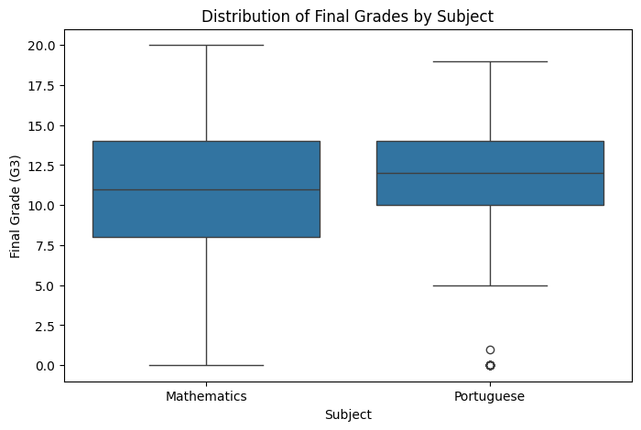Figure 1: Distribution of Final Grades by Subject
This comparison established the first part of the data story by showing that performance patterns were not identical across the two subjects.
- Previous Failures and Final Grade
A box plot was created to examine how previous academic failures were associated with final grades.
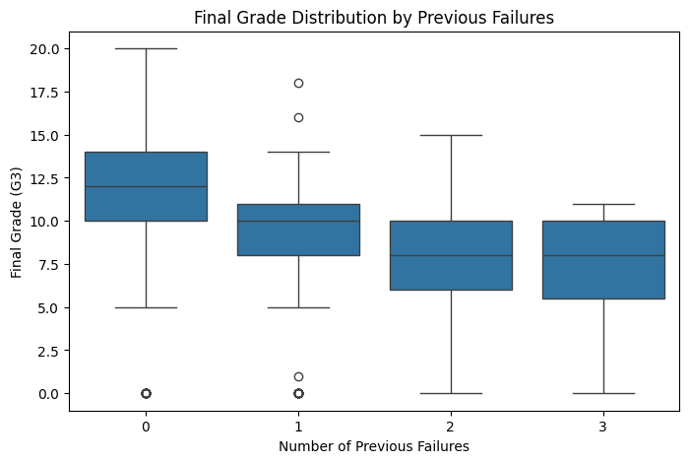
Figure 2: Final Grade Distribution by Previous Failures
The results showed a clear overall pattern: students with zero previous failures had the highest median final grades, while students with one or more previous failures generally had lower grades. Students with two or three previous failures showed particularly low median grades. Although individual exceptions existed, the overall pattern suggested that previous academic difficulties are an important indicator of future academic risk.
- Absence Range and Final Grade
A bar chart was created by grouping students into absence categories and calculating the average final grade for each group.
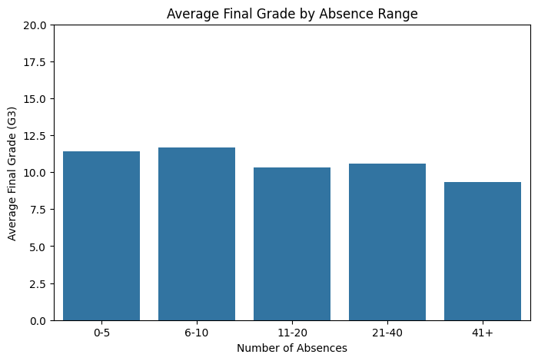
Figure 3: Average Final Grade by Absence Range
Students with lower absence levels generally achieved higher average grades. Students with extremely high absences, particularly the 41+ category, had the lowest average final grade. The relationship was not perfectly consistent across every absence category. This finding was later supported by correlation analysis, which showed that the overall linear relationship between absences and final grade was weak. Therefore, extremely high absenteeism may be more important than moderate variations in absences.
- Study Time and Final Grade
A bar chart was created to compare average final grades across study-time categories.
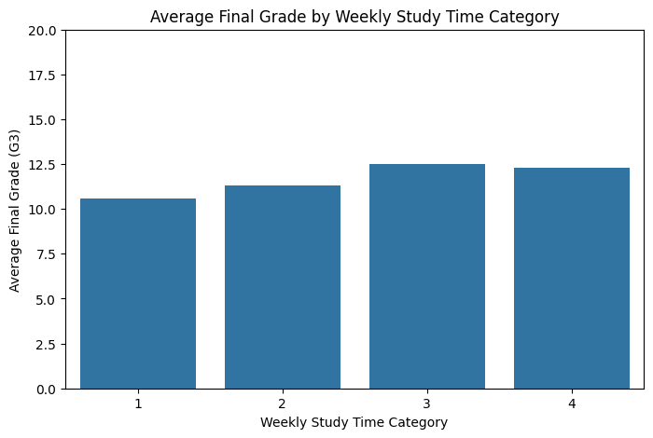
Figure 4: Average Final Grade by Weekly Study Time Category
The results showed a general positive pattern. Students in higher study-time categories generally achieved better average final grades. The relationship was not perfectly linear because the highest study-time category was slightly below Category 3, but both higher categories performed better overall than the lower categories. This exploratory finding was investigated further through statistical hypothesis testing.

STATISTICAL ANALYSIS AND HYPOTHESIS TESTING:
- Research Question
The statistical analysis investigated the following question:
Do students with higher study time have significantly different final grades compared with students with lower study time?
- Hypotheses

Null Hypothesis (H₀)
There is no statistically significant difference in mean final grades between students with lower and higher study time.

Alternative Hypothesis (H₁)
There is a statistically significant difference in mean final grades between students with lower and higher study time.

Significance Level
α = 0.05
Students with studytime values of 1 or 2 were classified as Lower Study Time, while students with values of 3 or 4 were classified as Higher Study Time.
The groups contained:
- Lower Study Time: 820 students
- Higher Study Time: 224 students
- Descriptive Results
Study-Time Group | Number of Students | Mean G3 | Median G3 | Standard Deviation
Lower Study Time | 820 | 11.04 | 11.00 | 3.83
Higher Study Time | 224 | 12.43 | 13.00 | 3.79
Students in the Higher Study Time group achieved an average final grade approximately 1.39 points higher than students in the Lower Study Time group. The standard deviations of the groups were similar.
- Statistical Method
Levene's test was first used to examine whether the two groups had significantly different variances. Since the analysis did not indicate a significant difference in variances, an independent samples t-test assuming equal variances was used.
A 95% confidence interval and Cohen's d effect size were also calculated to support interpretation of the difference.The statistical analysis provided formal evidence to complement the pattern already observed in the visualizations: students with higher study time demonstrated better academic performance than students with lower study time.
Code snippet:
from scipy.stats import ttest_ind
lower_study = combined_df[combined_df["studytime"].isin([1, 2])]["G3"]
higher_study = combined_df[combined_df["studytime"].isin([3, 4])]["G3"]
t_statistic, p_value = ttest_ind(
lower_study,
higher_study,
equal_var=True
)

MACHINE LEARNING MODEL DEVELOPMENT:
The machine learning stage aimed to classify students into two academic-performance categories.
A new binary target variable called performance was created:
- Lower Performance (0): G3 < 12
- Higher Performance (1): G3 ≥ 12
The final grade itself was excluded from the input features to prevent target leakage.
The dataset contained:
- Lower Performance: 534 students (51.15%)
- Higher Performance: 510 students (48.85%)
The relatively balanced class distribution reduced the risk of strong class-imbalance effects.
- Selected Features
Eleven features were selected for model development:
- Age
- Study time
- Previous failures
- Absences
- Mother's education
- Father's education
- Travel time
- Going out frequency
- Health status
- Family relationship quality
- Free time
The selected data contained no missing values and no duplicate records.
- Train-Test Split
An 80:20 train-test split was used:
- Training records: 835
- Testing records: 209
The random_state was set to 42 to ensure reproducibility, and stratified sampling was used to preserve the class distribution.
For Logistic Regression, the numerical features were standardised using StandardScaler. The scaler was fitted on the training data and then applied to the testing data to avoid information leakage.
Code snippet:
from sklearn.linear_model import LogisticRegression
model = LogisticRegression(max_iter=1000)
model.fit(X_train_scaled, y_train)
y_pred = model.predict(X_test_scaled)

MODEL SELECTION AND EVALUATION:
Two classification models were developed:
- Logistic Regression
- Decision Tree Classifier
Logistic Regression was selected as the primary model because it is suitable for binary classification and provides relatively interpretable results.
The Decision Tree was used as a comparison model because it can capture more complex and non-linear relationships. Its maximum depth was limited to 5 to reduce the risk of excessive model complexity.

- Logistic Regression Results
Metric | Result
Accuracy | 65.07%
Precision | 62.83%
Recall | 69.61%
F1-Score | 66.05%
ROC-AUC | 0.7076
The Logistic Regression model correctly classified 136 out of 209 testing records.
The training accuracy was 68.86%, while testing accuracy was 65.07%. The difference of 3.79 percentage points suggested that the model did not show severe overfitting.
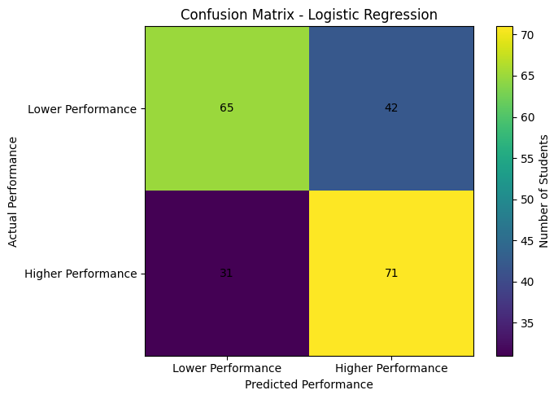
Figure 5: Logistic Regression Confusion Matrix
The model produced:
- 65 correct Lower Performance classifications
- 71 correct Higher Performance classifications
- 42 false positives
- 31 false negatives
The overall error rate was 34.93%, demonstrating that the model had useful but moderate predictive ability.
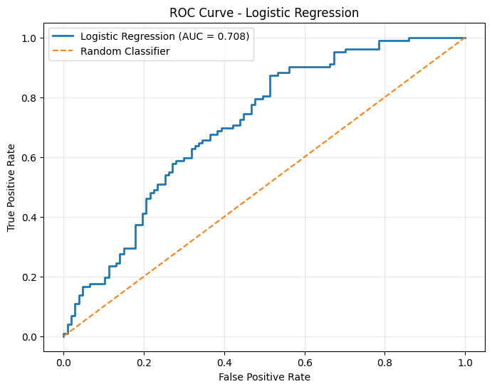
Figure 6: ROC Curve for Logistic Regression
The ROC-AUC value of 0.7076 indicated that the model performed better than random classification, but there was still substantial room for improvement.
- Decision Tree Results
The Decision Tree model was trained using the same training and testing data.
The Decision Tree achieved:
- Accuracy: 61.24%
- ROC-AUC: 0.6201
- Recall: 74.51%
Although the Decision Tree achieved higher recall, its overall accuracy and ROC-AUC were lower than those of Logistic Regression.
Therefore, Logistic Regression was selected as the better overall model for this project.

COMPREHENSIVE WEEK 5 ANALYSIS:
Week 5 integrated the results from the previous stages and focused on identifying the most important factors associated with final student performance.
- Correlation Analysis
The correlations between numerical variables and final grade (G3) were calculated.
The strongest relationships included:
Variable | Correlation with G3
G2 | 0.9107
G1 | 0.8091
Mother's Education (Medu) | 0.2015
Study Time | 0.1616
Father's Education (Fedu) | 0.1598
Previous Failures | -0.3831
Daily Alcohol Consumption | -0.1296
Age | -0.1253
Weekend Alcohol Consumption | -0.1157
Travel Time | -0.1026
The strongest positive correlations were G1 and G2 because they represent earlier academic performance. When these previous grades were excluded to focus on background and behavioural factors, previous failures showed the strongest negative relationship with final grade.
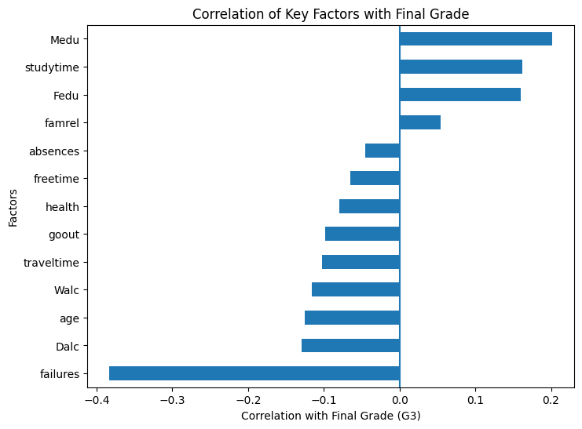
Figure 7: Correlation of Key Factors with Final Grade
The chart highlighted previous failures as the most important negative numerical factor among those analysed.
- Previous Failures
Previous failures had a correlation of approximately -0.383 with final grade, making it the strongest negative association among the selected student-related factors.
The box plot and correlation analysis both supported the same conclusion: students with more previous academic failures generally achieved lower final grades.
This was also important in the machine learning stage, where previous failures showed a strong negative association with predicted Higher Performance.
- Study Time
Study time had a positive correlation of approximately 0.162 with final grade.
The statistical analysis provided additional evidence. The Higher Study Time group achieved a mean final grade of 12.43, compared with 11.04 for the Lower Study Time group.
Therefore, study time emerged as a consistently useful factor across exploratory analysis, visualization, and statistical testing.
- Parental Education
Mother's education had a correlation of approximately 0.201, making it the strongest positive background factor among those examined after excluding previous grades.
Father's education also showed a positive correlation of approximately 0.160.
These relationships suggest that family educational background may be associated with academic performance. However, correlation alone does not prove that parental education directly causes higher student grades.
- Educational Aspirations
The categorical analysis showed a substantial difference between students who planned to pursue higher education and those who did not.
Average final grades were:
- Higher education aspiration = Yes: 11.62
- Higher education aspiration = No: 8.35
This was one of the largest differences identified among the categorical factors examined.
The finding suggests that student motivation, educational goals, and future aspirations may be important areas for academic support.
- School and Address
Average final grades were:
Category | Average G3
GP School | 11.63
MS School | 10.51
Urban Address | 11.62
Rural Address | 10.60
These differences may indicate variation in student circumstances or educational environments. However, the analysis does not establish the reasons for these differences.
- Internet Access
Average final grades were:
- Internet access = Yes: 11.55
- Internet access = No: 10.53
Students with internet access had a slightly higher average final grade.
This finding does not prove that internet access alone improves academic performance, but access to educational resources may be one factor worth considering.
- Alcohol Consumption
Daily and weekend alcohol consumption both showed negative correlations with final grade:
- Daily alcohol consumption: -0.1296
- Weekend alcohol consumption: -0.1157
These relationships were relatively weak compared with previous failures, but the negative direction suggests that unhealthy lifestyle patterns may be associated with lower academic performance.

KEY FINDINGS:
The following key findings emerged from the complete project:
- The combined dataset contained 1,044 student records from Mathematics and Portuguese courses.
- The dataset had 0 missing values and 0 duplicate rows, allowing the analysis to proceed without unnecessary data modification.
- Previous academic failures showed the strongest negative relationship with final grade among the analysed student-related numerical factors.
- Students with higher study-time categories generally achieved better final grades.
- Statistical analysis showed a meaningful difference between the Lower Study Time and Higher Study Time groups, with the Higher Study Time group achieving an average grade approximately 1.39 points higher.
- Mother's education showed the strongest positive correlation among the background factors examined, followed by study time and father's education.
- Students who planned to pursue higher education had substantially higher average final grades than students who did not.
- Students with internet access had a slightly higher average final grade.
- Students with extremely high absences showed lower average performance, although the overall linear correlation between absences and final grade was weak.
- Logistic Regression achieved better overall performance than the Decision Tree model, with 65.07% accuracy and 0.7076 ROC-AUC.
- Machine learning demonstrated that student-related variables can identify useful patterns, but the moderate model performance means predictions should not be used as the sole basis for individual educational decisions.

STRATEGIC RECOMMENDATIONS:

Early Intervention for Students with Previous Failures
Students with previous academic failures should be identified early and provided with targeted support. This may include remedial classes, mentoring, additional learning resources, and regular academic progress monitoring.
Since previous failures showed the strongest negative association with final grade, this group may benefit most from early intervention.

Encourage Consistent Study Habits
Schools can encourage students to develop regular and structured study routines. Study-planning sessions, time-management guidance, and academic support programmes may be particularly useful for students in lower study-time categories.
The exploratory and statistical analyses both indicated that higher study time was associated with better academic performance.
Strengthen Educational Aspirations
The substantial difference between students who planned to pursue higher education and those who did not suggests that educational goals may be associated with academic motivation.
Career guidance, higher-education awareness programmes, and mentoring may help students understand future educational opportunities and develop stronger academic goals.
Monitor Extremely High Absenteeism
The absence analysis suggested that students with very high absence levels had lower average final grades. Schools can use attendance monitoring systems to identify chronic absenteeism early and provide appropriate support, including communication with students and families and academic catch-up assistance.
Improve Access to Learning Resources
Students without internet access had a lower average final grade than students with access.
Educational institutions can consider improving access to digital learning materials, computer facilities, libraries, and other academic resources, particularly for students with limited access outside school.
Promote Healthy Student Behaviour
The negative relationships observed for daily and weekend alcohol consumption suggest that student well-being and lifestyle behaviour should be considered alongside academic support.
Awareness programmes can promote healthy choices and explain how lifestyle factors may affect academic engagement.
Use Data to Support, Not Replace, Educational Decisions
The machine learning model demonstrated useful predictive ability but had a 34.93% error rate. Therefore, predictive results should be treated as an additional source of information rather than an automatic decision-making system.
Teachers and educational institutions should combine data-driven insights with professional judgment and knowledge of individual student circumstances.

POTENTIAL EDUCATIONAL IMPACT:
The findings of this project could support educational decision-making in several ways.
First, academic institutions could use student data to identify students who may require additional support. Factors such as previous failures, study habits, attendance, and educational aspirations could help identify potential academic risks.
Second, the findings could support the development of targeted interventions instead of applying the same approach to every student. For example, students with previous failures may require academic support, while students with low study time may benefit from study-planning guidance.
Third, the project demonstrates how data visualization can make complex student information easier to understand. Teachers and administrators may use clear charts and summaries to identify broad patterns and communicate findings.
Finally, the machine learning component demonstrates the potential of predictive analysis. However, such models should be used responsibly because moderate accuracy and prediction errors can affect the reliability of individual predictions.

LIMITATIONS OF THE PROJECT:
Several limitations should be considered when interpreting the findings.

1. Correlation Does Not Prove Causation
The relationships identified in the analysis show associations between variables. They do not prove that one factor directly causes changes in academic performance.

2. Combined Subject Data
The project combined Mathematics and Portuguese records. Differences between the subjects may influence performance patterns.

3. Cross-Sectional Dataset
The dataset represents student information available at a particular stage and does not track changes in individual students over a long period.

4. Limited Machine Learning Features
Only 11 selected features were used for machine learning. Other relevant factors may not have been included.

5. Binary Performance Classification
The machine learning task simplified final grades into two categories using a cutoff of G3 = 12. This approach may lose information contained in the original 0–20 grade scale.

6. Moderate Model Performance
Although Logistic Regression performed better than the Decision Tree model, an accuracy of 65.07% and an error rate of 34.93% show that the model is not sufficiently reliable to make individual student decisions independently.

7. Potential Unobserved Factors
Student performance may also be influenced by factors not available in the dataset, such as teaching quality, learning difficulties, economic circumstances, or individual personal situations.

FUTURE IMPROVEMENTS:
The project could be improved in several ways.

Use Cross-Validation
Cross-validation could provide a more robust estimate of model performance than relying on a single train-test split.

Perform Hyperparameter Tuning
The machine learning models could be improved by systematically tuning their parameters.

Test Additional Algorithms
Future work could compare additional algorithms such as Random Forest, Support Vector Machine, Gradient Boosting, or other suitable models.
Predict the Actual Final Grade
Instead of classifying students into two categories, future work could use regression techniques to predict the actual numerical final grade.

Include Additional Relevant Features
Additional carefully selected variables could provide more information for the analysis and improve predictive performance. Any feature selection should avoid target leakage.

Conduct Separate Subject Analysis
Mathematics and Portuguese students could be analysed separately to determine whether the relationships between factors and performance differ by subject.

Use Longitudinal Data
Future research could analyse student performance over time to better understand changes in academic progress.
These improvements are consistent with the areas identified during the machine learning evaluation.

CONCLUSION:
This five-week Data Science with Python project demonstrated a complete end-to-end data science workflow using the Student Performance dataset.
The project began with data acquisition, inspection, cleaning, and exploratory analysis. The dataset was then examined through advanced visualizations to identify and communicate important patterns. Statistical hypothesis testing was used to examine the relationship between study time and academic performance. Machine learning models were subsequently developed to classify students into Lower Performance and Higher Performance groups.
The comprehensive analysis showed that student performance is associated with multiple academic, family, social, and behavioural factors. Previous academic failures emerged as the strongest negative factor among the student-related numerical variables examined. Study time and parental education showed positive associations with final grades, while students who planned to pursue higher education demonstrated substantially better average performance.
The machine learning analysis showed that Logistic Regression was the better overall model compared with the Decision Tree, achieving 65.07% accuracy and a ROC-AUC of 0.7076. However, the model's moderate performance and 34.93% error rate demonstrate the importance of interpreting predictive results carefully.
Overall, the project demonstrates how data acquisition, cleaning, exploratory analysis, visualization, statistical testing, and machine learning can be integrated to understand a real-world problem. The final findings were translated into strategic recommendations focused on early academic intervention, effective study habits, educational aspirations, attendance monitoring, access to learning resources, and responsible use of data-driven tools.

